**Testing Documentation**

This document explains how to run tests, what scenarios are covered, and lists the HTTP APIs with sample requests and responses **matching the current tests**

**1. How to Run**

**Run tests**

| # from repo root ./mvnw clean test |
| --- |

**Profiles**: tests run with api/src/test/resources/**application-test.yml**. **2. Unit Test**

**2.1 CurrencyControllerTest**

Tests CurrencyController APIs with MockMvc for fetching and adding currencies using mocked dependencies

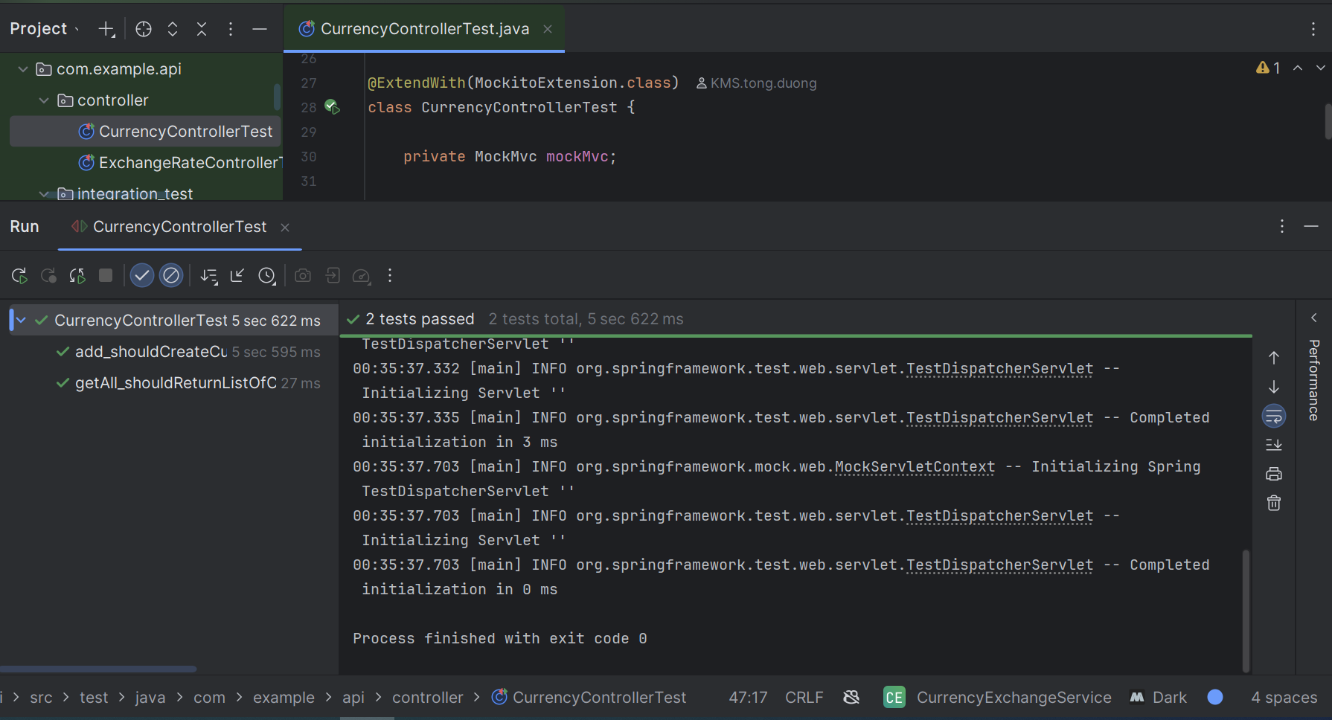

**2.2 ExchangeRateControllerTest**

Tests ExchangeRateController APIs with MockMvc for fetching exchange rates (by base, by base & quote, and live rates) using mocked service and mapper.

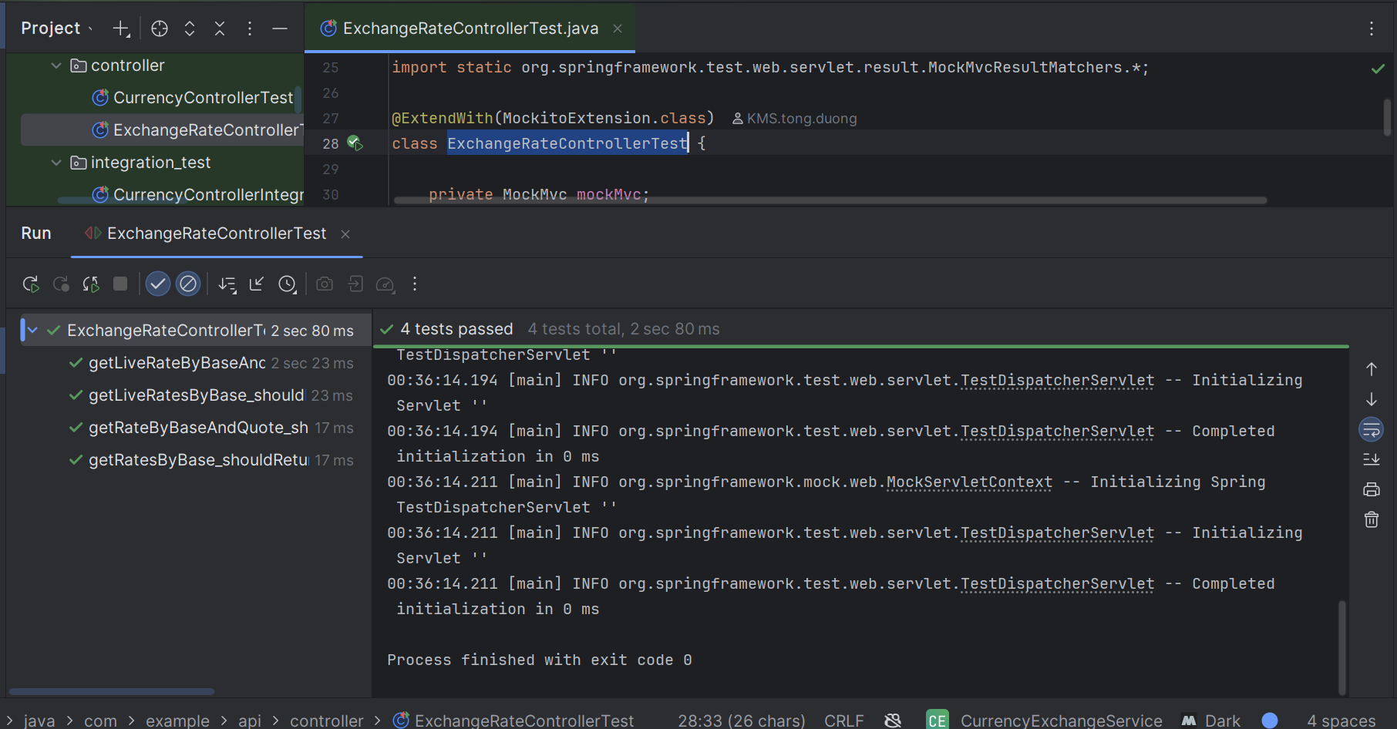

**2.3 ExchangeRateSyncJobUnitTest**

Tests ExchangeRateSyncJob to ensure it skips when no currencies exist and runs async rate fetch for each available currency.

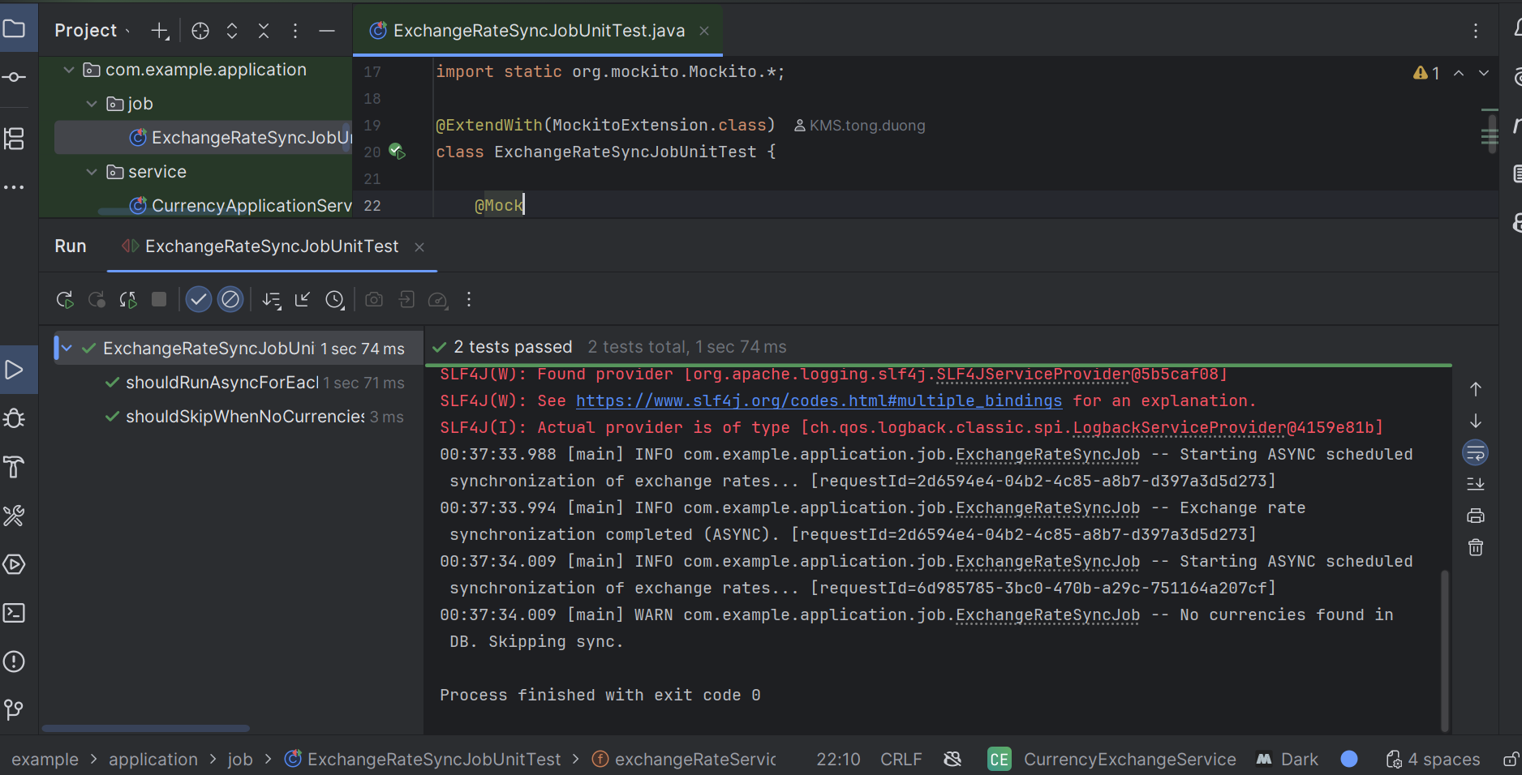

**2.4 CurrencyApplicationServiceImplTest**

Tests CurrencyApplicationServiceImpl to verify CRUD operations delegate correctly to the domain service and mapper, returning expected CurrencyDto results.

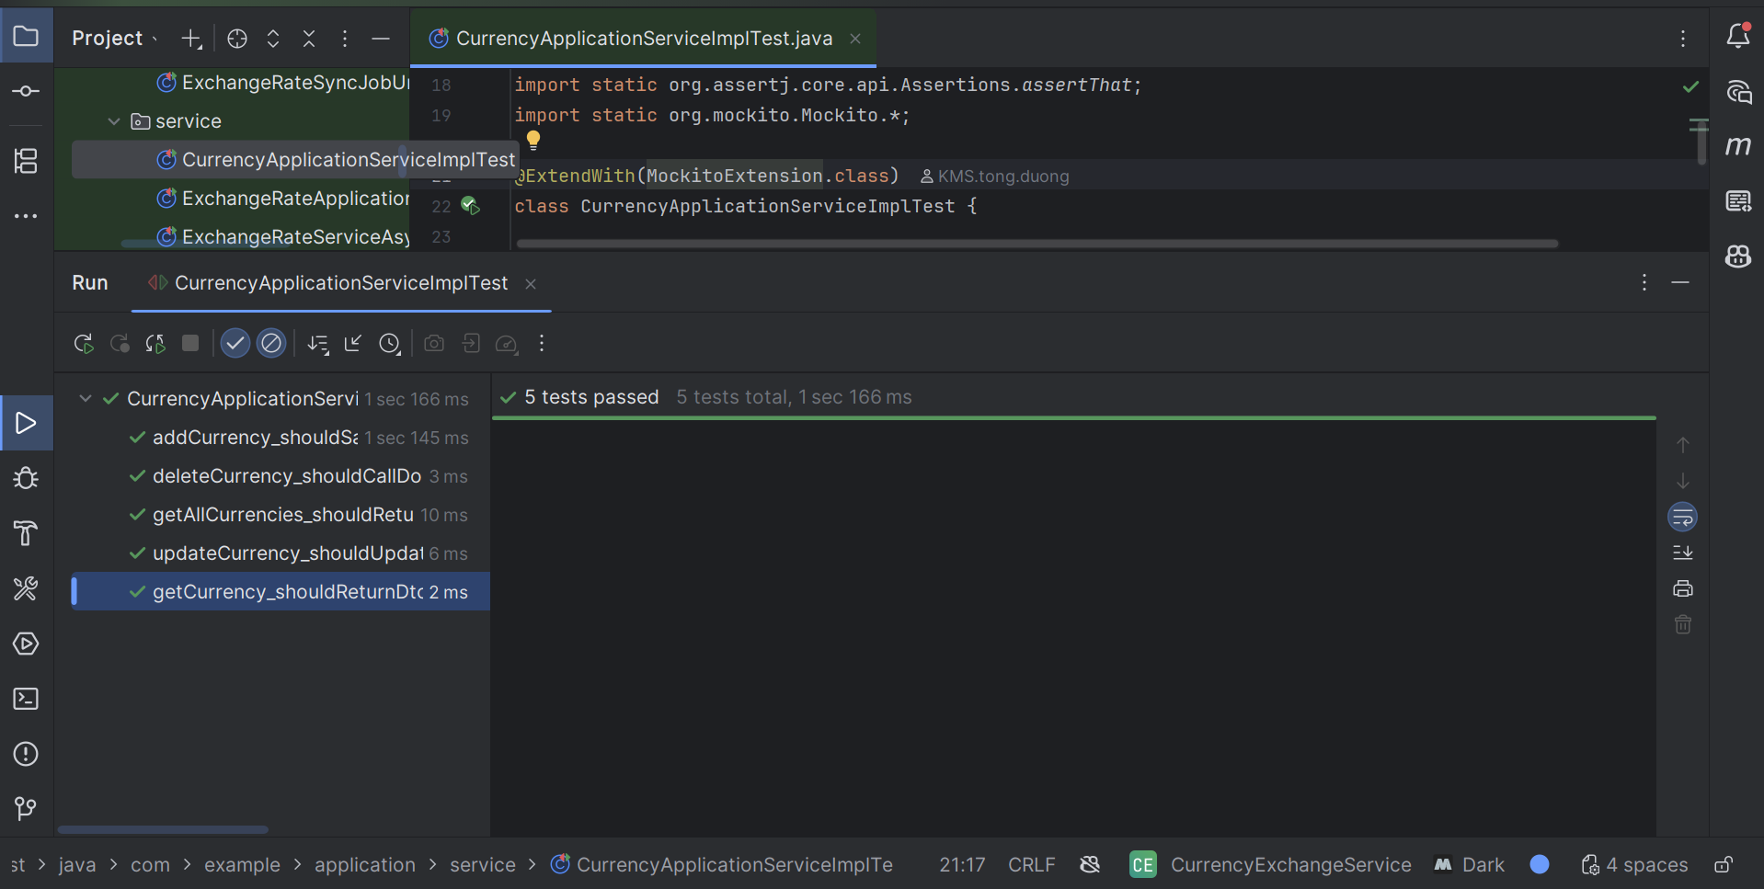

**2.5 ExchangeRateApplicationServiceImplTest**

Tests ExchangeRateApplicationServiceImpl to ensure exchange rate retrieval, live API fetch, error handling, and save/update operations work correctly with mocked repository, API client, and mapper.

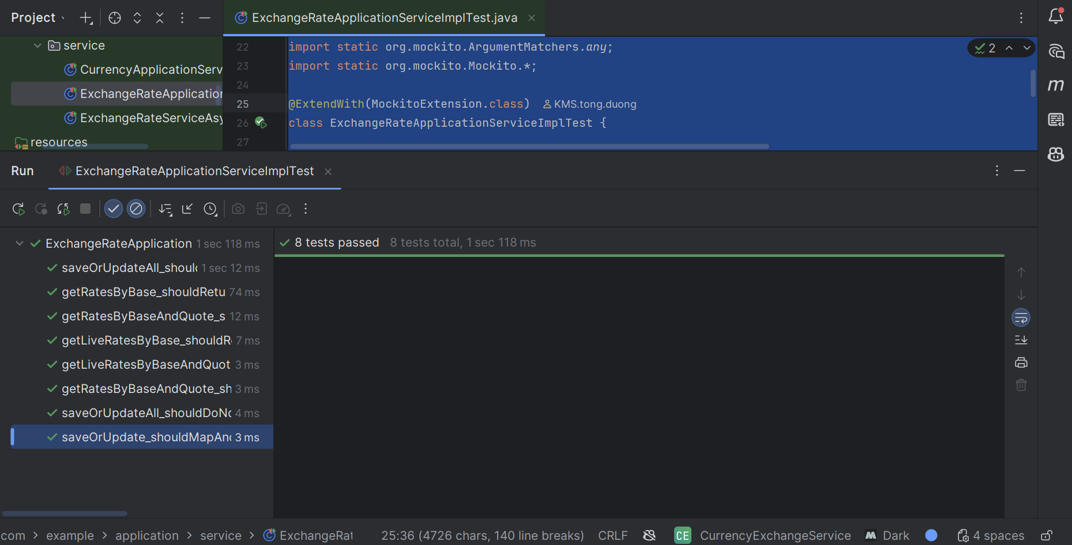

**2.6 ExchangeRateServiceAsyncImplTest**

Tests ExchangeRateServiceAsyncImpl to ensure async rate fetching saves results via ExchangeRateApplicationService, and gracefully handles exceptions without saving.

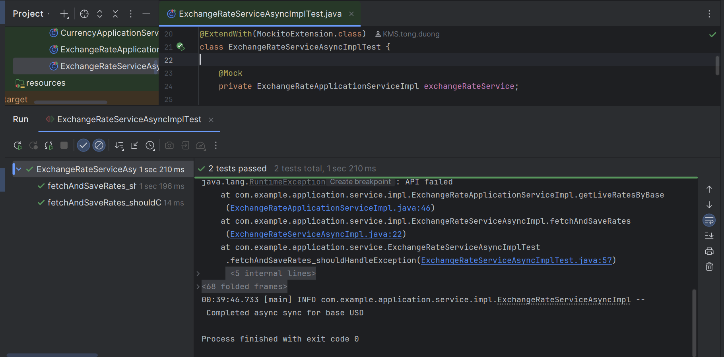

**2.7 CurrencyRepositoryAdapterTest**

Tests CurrencyRepositoryAdapter to verify JPA repository and mapper integration for find, save, and delete operations on Currency.

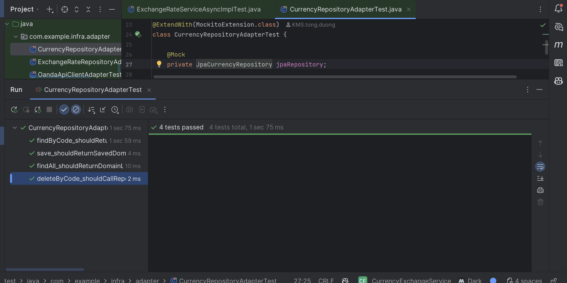

**2.8 ExchangeRateRepositoryAdapterTestTests**

ExchangeRateRepositoryAdapter to ensure save, update, batch save, find, and delete operations correctly interact with JPA repository and mapper.

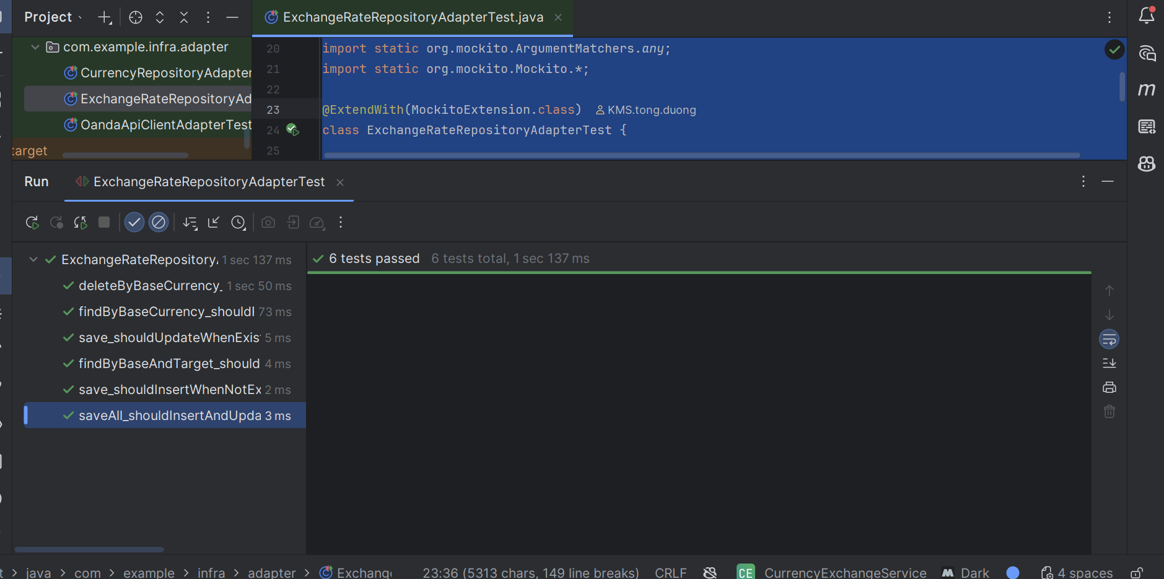

**2.9 OandaApiClientAdapterTest**

Tests OandaApiClientAdapter to ensure it correctly maps API responses to ExchangeRate, throws on empty results, and fetches rates for all target currencies of a given base.

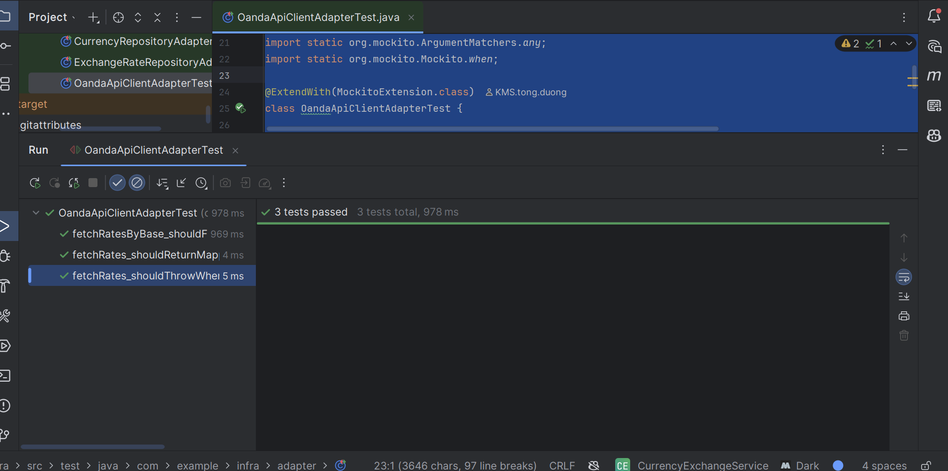

**3. Integration Test**

**3.1.CurrencyControllerIntegrationTest**

Integration test for CurrencyController covering full CRUD flow: add, retrieve all, get by code, update, delete, and verify database state.

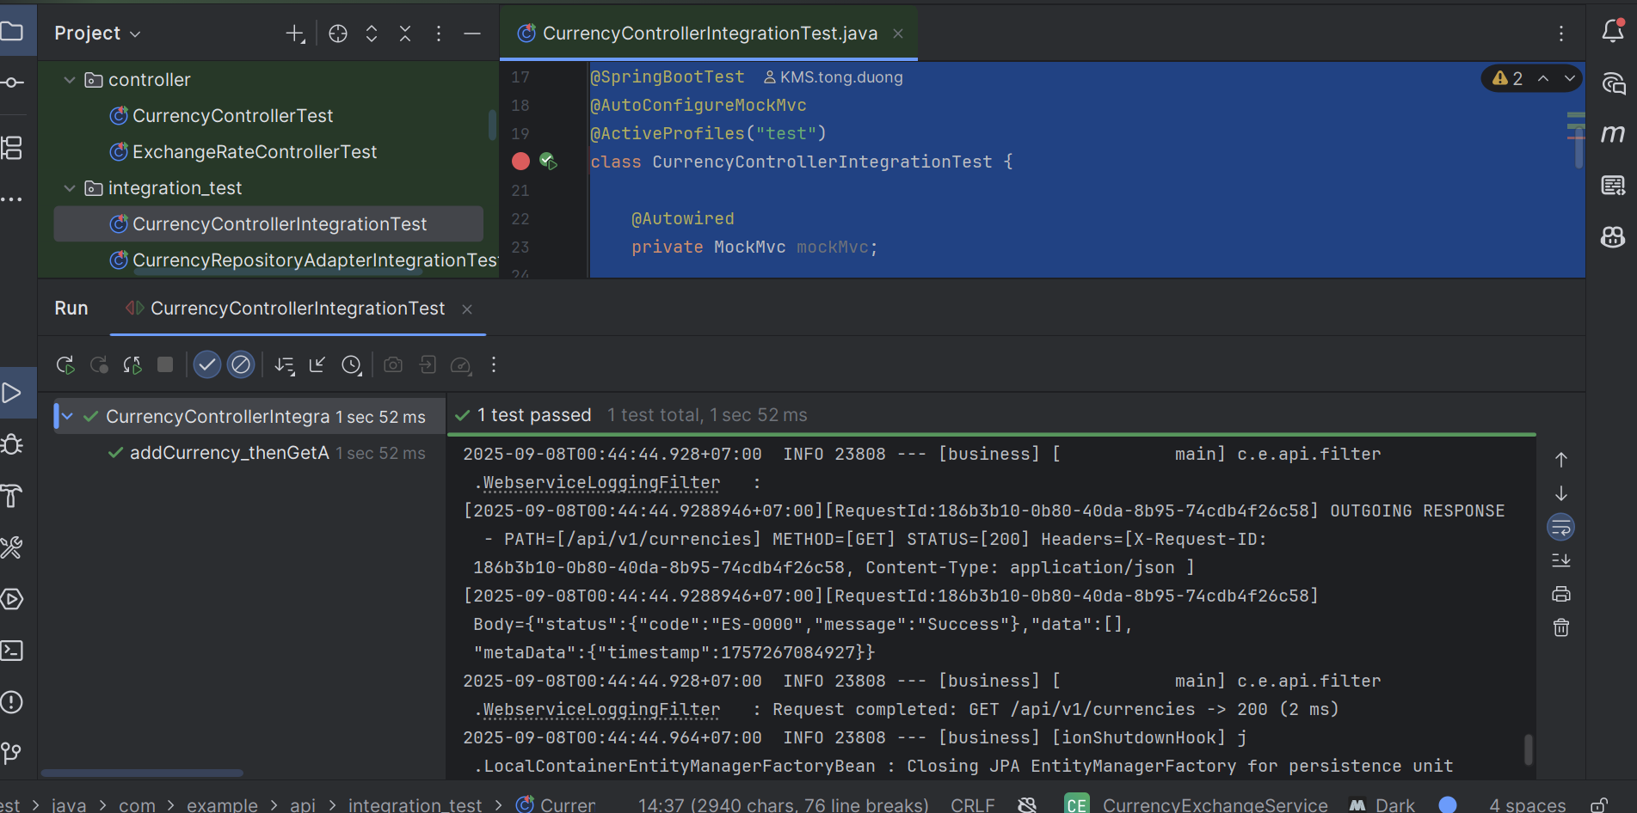

**3.2.CurrencyRepositoryAdapterIntegrationTest**

Integration test for CurrencyRepositoryAdapter verifying persistence operations: save, find by code, find all, and delete**.**

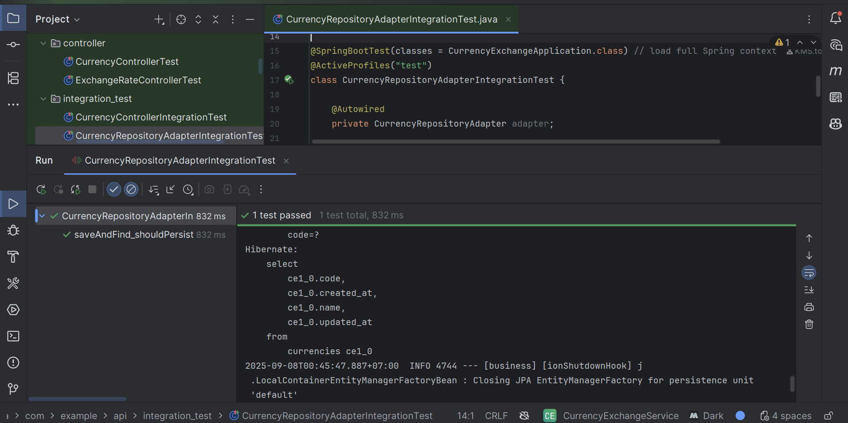

**3.3.ExchangeRateControllerIntegrationTestIntegration test for** ExchangeRateController verifying DB-backed queries and live Oanda API endpoints for fetching exchange rates.

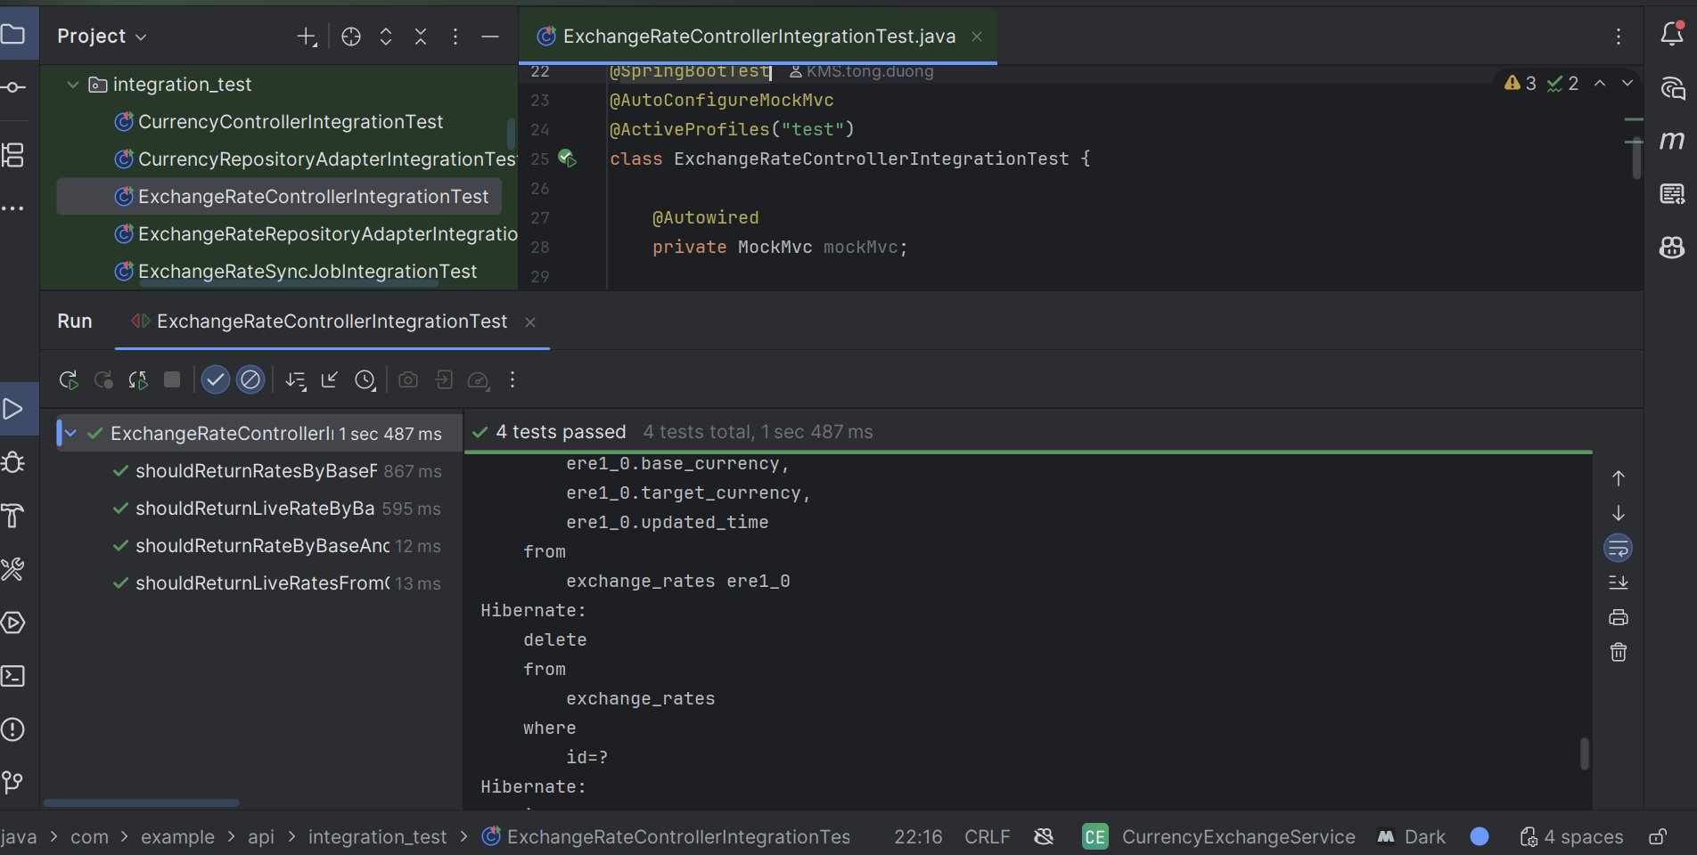

**3.4.ExchangeRateRepositoryAdapterIntegrationTest**

Integration test for ExchangeRateRepositoryAdapter verifying persistence operations: save, update if exists, batch insert, query, and delete by base currency.

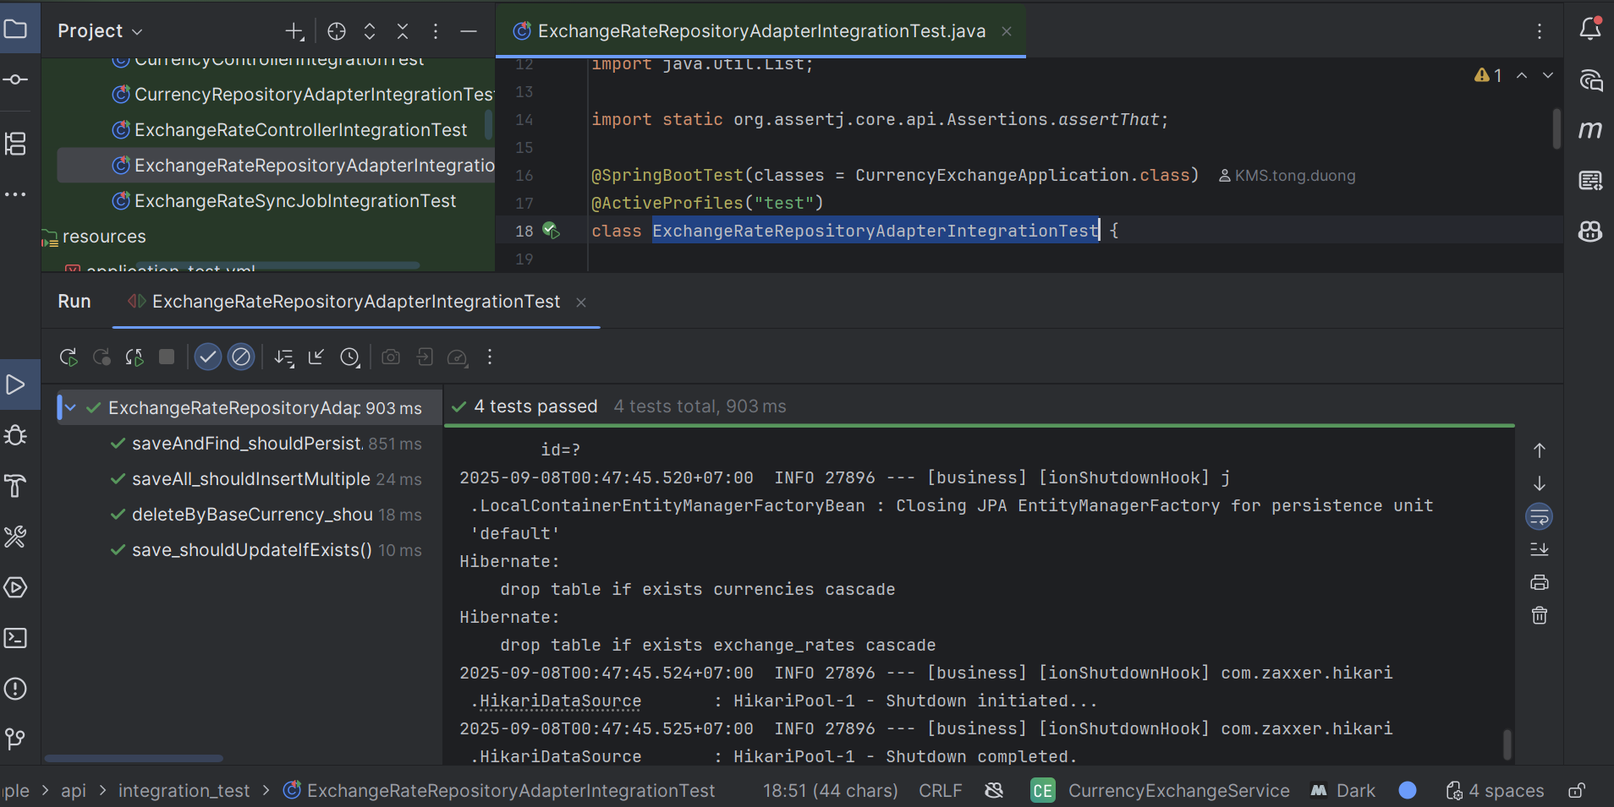

**3.5. ExchangeRateSyncJobIntegrationTest**

Integration test for ExchangeRateSyncJob verifying it fetches live rates and persists them in the database for available currencies.

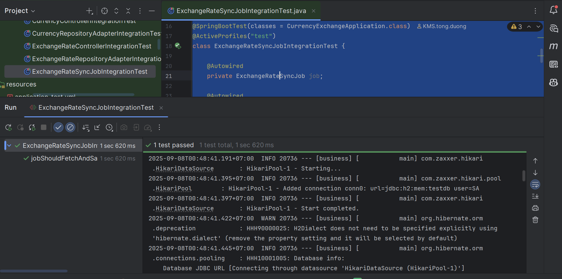

**4. Manual Test**

Please refer to the attached XLS file and Postman collection